Learning Guide 4
2.3B Factors affecting the rate of dissolving
Name: ____________________

Class: __________ ( ) Date: ____________________
Dictionary
(with pronunciation)

Objectives:
Knowledge: Recognize the factors affecting the rate of dissolving.
Skill: Perform fair tests to study the how volume of water affecting the rate of dissolving.
Use AI as a data analyst to evaluate data reliability and error sources.
Attitude: Take ownership of learning by predicting, verifying, and using AI coaching to deepen scientific reasoning.

 Keywords
- Underline the vowels (a, e, i, o, u) and break up the words into syllables (only for the first word).
- Check the dictionary/textbook and write the Chinese meaning of the words in the brackets provided.
- Review the keywords and prepare for dictation.

Factors affecting the rate of dissolving | Diagrams
- size (noun) ( ) | /
- volume (noun) ( ) | /
- temperature (noun) ( ) | /
- mass (noun) ( ) | /
- stir (verb) ( ) | 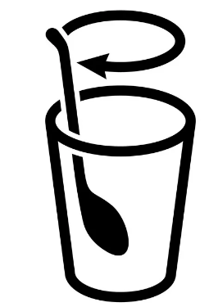
- increase (verb) ( ) | 
- decrease (verb) ( ) | 
Hints: 大小、溫度、體積、上升、下降、攪拌、質量
Preparation Questions
(Read textbook P.95–100 and answer the following questions)
(Check the Chinese meaning of the words highlighted before lesson)

Think-pair-share The Morning Drink
Q1. Think: You want to dissolve salt faster. What can you do?

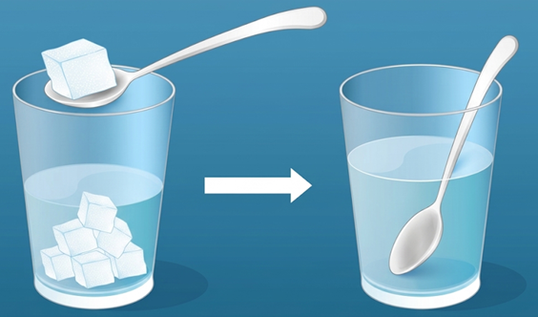
I can dissolve salt faster by ______________________________
______________________________



Pair: Pair-up with your groupmates and share your thoughts.
Share: Discuss your methods with whole class.

Language Support:

If we say something dissolves faster, that means it has a higher rate of dissolving.

Pre-lab Session
Q2. We are going to carry out fair tests to study how volume of water affect the rate of dissolving.
Complete the table below.
Hypothesis | The rate of dissolving of salt in water ____________________ (increases / decreases) if more water is used.
Variable to be changed | ________________________________________
Variables to be compared | _______________ needed for the salt to completely dissolve in water
Variables to be kept constant  (Put “” in the box(es)) |  Temperature of water   Volume of water   Mass of salt   Size of salt pieces

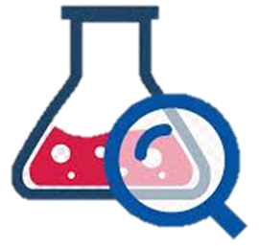 Experiment Time: Experiment 2.5 – Factors affecting the rate of dissolving

Step 1 | Prepare 50 cm³, 100 cm³, 150 cm³ and 200 cm³ of water in four beakers of the same size.
  
  50 cm³ | 100 cm³ | 150 cm³ | 200 cm³
Step 2 | 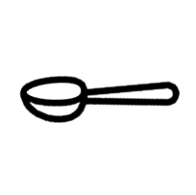    Add a spatula of salt and start the stopwatch. Stir the liquid with a glass rod until all salt dissolved.  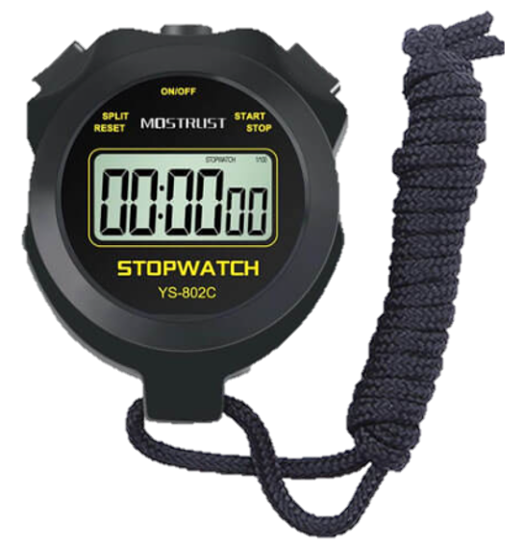  
Step 3 | Record the time taken for all the salt dissolved.

Results:
Volume of water | 50 cm³ | 100 cm³ | 150 cm³ | 200 cm³
Time needed for the salt to completely dissolve in water | __________ s | __________ s | __________ s | __________ s

Input your data into Agent Water. He may ask you some interesting questions. Try to answer him and record what you have learnt through the conversation.


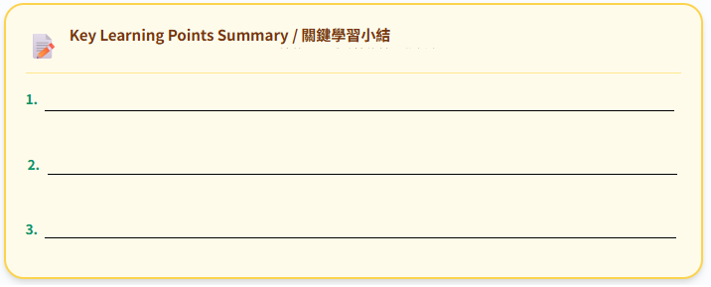
Agent Water
Conclusion:
Salt dissolves _______________ (faster / slower) if more volume of water is used.

Reflection:

High-order thinking questions:
Q1. Why do we take average of eight groups of the reading?
_________________________________________________________________________________
_________________________________________________________________________________

Q2. Suggest limitations of this experiment and some methods to make the results more reliable.
_________________________________________________________________________________
_________________________________________________________________________________
_________________________________________________________________________________

Extension:
The rate of dissolving depends on many other factors. Try to design and carry out fair tests to study how different factors affect the rate of dissolving.

Factors | Comparison |  |  | Checklist
Volume of water | more water | V.S. | less water | ☑ | (Done in this lesson)
Stirring | stirred | V.S. | not stirred | 
Size of the solute pieces | powdered salt | V.S. | salt cube | 
Temperature | hot water | V.S. | cold water | ☑ | (Done in Ch1)

